FORUM: Third Committee to the General Assembly (SOCHUM)
QUESTION OF: Protecting Child refugees in Camps
STUDENT OFFICER: Lara Wischnewski
POSITION: Deputy-Chair

INTRODUCTION:
Nowadays, there are more than 65.6 million individuals that have been forcibly displaced for various reasons. Religious, national, social, political persecutions, hunger and war are the main reasons for that. Children make up more than 30% of all asylum seekers across Europe and more than 50% worldwide. In 2017, European countries recorded 209,756 asylum claims by children, including 50,325 newly registered asylum claims during the last quarter of 2017. Half of all child asylum seekers came from just three countries: Syrian Arab Republic (27%), Iraq (10%) and Afghanistan (10%).
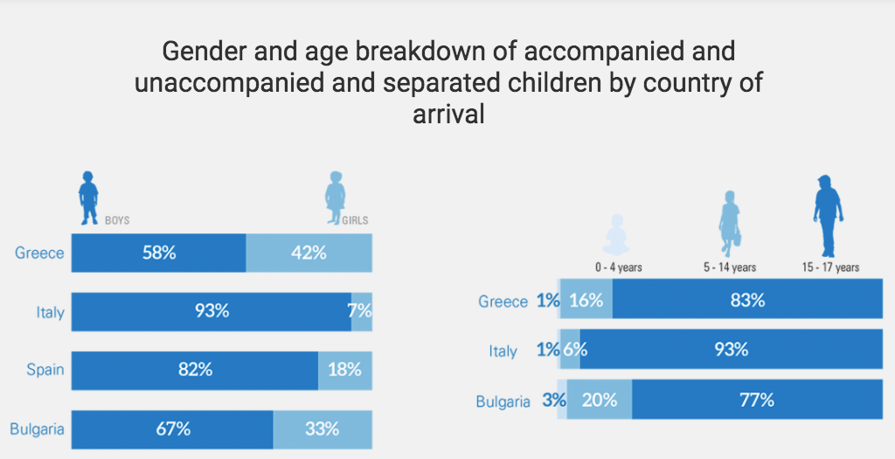
SCOPE OF THE PROBLEM:
Refugee children have faced quite more difficulties and dangers to their life than any other average children. Migrant and displaced children face many challenges in transit and at destination, often because many of them have limited options to move through safe pathways and with their families. They often encounter violence, abuse, exploitation or discrimination.
Despite the fact, that children are placed in the refugee camps that provide immediate protection and safety for the world’s most vulnerable people, they still face many challenges, such as but not limited to:
- Mental health issues
It is estimated that 50 percent of refugee children fleeing Syria have Post Traumatic Stress Disorder due to the actions they have witnessed or experienced, however, only 5 percent of them who have resettled in Lebanon, Jordan and Turkey are receiving psychological support.
- Lack of education
UNHCR estimates that only 43 percent of refugee children have a primary education as opposed to a global average of 90 percent.
- Abuse, violence, trafficking
While fleeing their country of origin, many unaccompanied children end up travelling with traffickers who may attempt to exploit them as workers. Including adults, sex trafficking is more prevalent in Europe and Central Asia.
- Language barrier
A broad spectrum of translation services are available to all refugees, but only a small number of those services are government-sponsored. Community health organizations provide a majority of translation services, but there are a shortage of funds and available programs. Since children and adolescents have a greater capacity to adopt their host country's language and cultural practices, they are often used as linguistic intermediaries between service providers and their parents. This may result in increased tension in family dynamics where culturally sensitive roles are reversed.

KEY TERMS:
-Refugee: A person who has been forced to flee his or her country because of persecution, war or violence. A refugee has a well-founded fear of persecution for reasons of race, religion, nationality, political opinion or membership in a particular social group. Most likely, they cannot return home or are afraid to do so. War and ethnic, tribal and religious violence are leading causes of refugees fleeing their countries.

-Internally displaced person: IDP, is someone who has been forced to flee their home but never cross an international border. These individuals seek safety anywhere they can find it—in nearby towns, schools, settlements, internal camps, even forests and fields. IDPs, which include people displaced by internal strife and natural disasters, are the largest group that UNHCR assists. Unlike refugees, IDPs are not protected by international law or eligible to receive many types of aid because they are legally under the protection of their own government.

-Asylum seeker: someone whose request for sanctuary has yet to be processed. An asylum seeker must demonstrate that his or her fear of persecution in his or her home country is well-founded. Every year, around one million people seek asylum.

-Convention on the Rights of the Child: A human rights treaty which sets out the
civil, political, economic, social, health and cultural rights of children.

-UNICEF: United Nations Children's Fund: an agency, created by the
United Nations General Assembly in 1946, concerned with improving the
health and nutrition of children and mothers throughout the world.

-UNHCR: the UN Refugee Agency, is a global organization dedicated to saving lives, protecting rights and building a better future for refugees, forcibly displaced communities and stateless people.

EXPECTATIONS FOR POSITION PAPER:
You are expected to write a Position Paper that is a minimum of two pages long. The Position Paper should contain general information on the issue in relation to your country and specific policies your country introduced to act upon this issue.

Further questions you could also consider during your research:
-Is your country involved in solving this issue?
-What were your country’s past actions regarding the issue?
-What is your county’s position on this issue?
-Has your country signed any treaties in regards to protect child refugees in camps?

USEFUL LINKS/SOURCES:
UNHCR Policy on Refugee Children:
http://www.unhcr.org/protect/PROTECTION/3b84c6c67.pdf
UNICEF’s latest statistics and graphics on refugee and migrant children:
https://www.unicef.org/eca/what-we-do/emergencies/latest-statistics-and-graphics-refugee-and-migrant-children
Statistics of UNHCR's populations of concern:
http://popstats.unhcr.org/en/overview#_ga=2.166280638.1879887220.1534281442-254574840.1534281442

