FORUM: Sixth Committee to the General Assembly (LEGAL)
QUESTION OF: Establishing guidelines for member states to issue identification papers to refugees
STUDENT OFFICER: Leopold Lingenberg
POSITION: Main-Chair

INTRODUCTION:
In 2016 the United Nations High Commissioner for Refugees (UNHCR) reported that forced displacement from conflict or persecution was at an all-time global high and that the numbers were constantly rising. An approximate amount 65.3 million people were displaced as at the end of 2015, an almost 10 per cent increase from the previous year.
Their lack of verifiable identity is what frequently complicates the effort to protect vulnerable people. Whether due to failures of government in their country of origin, the need to flee without supporting documentation, or the destruction of such supporting information, those most in need of protection are often those with the most limited access to documentation that verifies their identity to an administrative standard.
Most states have developed legislative and procedural requirements to meet the challenge of verifying identity, which is well known for states in receipt of asylum seekers. Yet there is no recognized international consensus about how to best establish an individual’s identity.

SCOPE OF THE PROBLEM:
Weak Governance: Temporary or structurally weak oversights of government administrations in countries of origin sets the predominant challenge for states in receipt of asylum seekers in cases of forced displacement. Consequently, in many cases asylum seekers are unable to obtain documents to the standards required by the assessing country.
Complex ethnic interactions and statelessness: In the case of some persecuted peoples, racial and ethnic identity is complex and difficult to distinguish. This is perhaps best exemplified by the case of the Rohingya in Myanmar. Generally, Myanmar has a complex system of identity interaction, involving elements of race and ethnicity, religion, language, and geographic location.
Document destruction: Being advised by people smugglers, some asylum seekers admitted to have destroyed their documents for a range of reasons.
In some cases, asylum seekers have been found to have purposely destroyed or disposed of documentation in an effort to cloud the opportunities for their return (in most cases a country in receipt of a failed asylum seeker requires a confirmed identity before accepting their return). The destruction or disposal of documents is not a comprehensive indication of fraud, and those who eradicate evidence of their identity may still have recognizable claims under the legislation. However, such actions may indicate an attempt to obfuscate and complicate the identification process.
Security: Within the last years the increasing threat through i.e. terrorism has led to a rising suspicion to asylum seekers worldwide. Following that, these migrants have a national security profile due to the opportunities an unmanaged and chaotic migration policy offers to inter- and transnational threats. A lack of verifiable identity documents increases exposure to such risk and raises suspicion in the receiving community.

HISTORIC DEVELOPMENT:

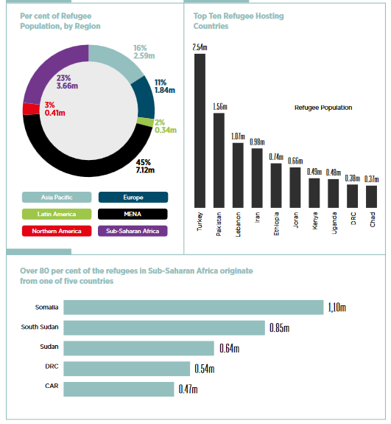
The Nansen passports were internationally recognized refugee travel documents introduced in 1922. They were the response to the unprecedented wave of refugees after World War I. At the The Refugee Convention, 1951 the so called “1951 Convention travel document” was introduced. Within Article 28 a definition of the basic properties of the document can be found. The Issue was further discussed in the following years but not much unified progress was made on the issue of identification documents.The UNHCR (United Nations Refugee Agency) has discussed some of the observable problems in one of its articles for example: “9. Identity papers which show only the name, the date and place of birth, and the current address of the refugee would satisfy the literal requirements [...]. For purposes of international protection, however, it is often essential that such identity papers also indicate the holder’s refugee status. Proof of refugee status may be of vital importance, for example, in situations where refugees are caught up in police operations directed against aliens whose presence in the country is considered unlawful.”

KEY TERMS:
-Refugee: A displaced person who has been forced to cross national boundaries and who cannot return home safely (for more detail see legal definition).

-Travel document: A travel document is an identity document issued by a government or international treaty organization to facilitate the movement of individuals or small groups of persons across international boundaries, following international agreements.

-Identity: In this context a proof of personal identification, citizenship, habitual residence, ethnic group and language.

-Identity as claimed: The unverified identity of the applicant as claimed to authorities.
-Identity supported: Applicant’s claimed identity is supported by a combination of the three pillars of identity (narrative, biometrics, documentation).

-Identity confirmed: Genuine identity document produced and no adverse information around identity.

EXPECTATIONS FOR POSITION PAPER:
You are expected to write a Position Paper that is a minimum of two pages long. The Position Paper should contain general information on the issue in relation to your country and specific policies your country introduced to act upon this issue.

Further questions you could also consider during your research:

-How is your countries refugee policy?

-Which measures are already taken by your country regarding to the issue?

-How far is your country affected by migration causing crisis?

-Which unified regulations on the issue would your country implement?

USEFUL LINKS/SOURCES:
THE REFUGEE CONVENTION, 1951; Article 27 and Article 28: http://www.unhcr.org/4ca34be29.pdf#%5B%7B%22num%22%3A954%2C%22gen%22%3A0%7D%2C%7B%22name%22%3A%22FitB%22%7D%5D
http://www.refworld.org/docid/3ae68cd90.html;

Refugees and Identity: Considerations for mobile-enabled registration and aid delivery:
https://www.gsma.com/mobilefordevelopment/wp-content/uploads/2017/06/Refugees-and-Identity.pdf;

Identity Documents for Refugees EC/SCP/33:
http://www.unhcr.org/excom/scip/3ae68cce4/identity-documents-refugees.html#_ftnref2;

US Embassy, Kabul, “A Guide to Afghan Documents”, June 2011, 3: https://wikileaks.org/gifiles/attach/10/10776_US%20Embassy%20Kab.pdf;

COUNCIL DIRECTIVE 2004/83/ECof 29 April 2004 on minimum standards for the qualification and status of third country nationals or stateless persons as refugees or as persons who otherwise need international protection and the content of the protection granted:
https://eur-lex.europa.eu/LexUriServ/LexUriServ.do?uri=CELEX:32004L0083:en:HTML;

UNHCR, “Global Trends: Forced Displacement in 2015”, 14 June 2016: https://s3.amazonaws.com/unhcrsharedmedia/2016/2016-06-20-global-trends/…;

https://en.wikipedia.org/wiki/Refugee

http://www.unhcr.org/4ca34be29.pdf#%5B%7B%22num%22%3A191%2C%22gen%22%3A0%7D%2C%7B%22name%22%3A%22FitB%22%7D%5D

